Lab Exercise 4- Signed Commits in Git and GitHub

Objective:
To configure Git to sign commits with GPG, push them to GitHub, and verify commit authenticity for secure code contribution.
Prerequisites:
- Git installed on your system
- GPG (GNU Privacy Guard) installed and configured
- GitHub account with a repository (you own or have write access to)
- Basic knowledge of Git commands

- Step 1 – Generate or Use an Existing GPG Key
- Check for existing keys
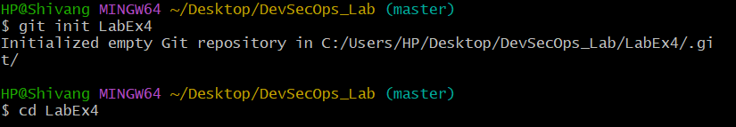

- If no key exists, generate a new one
  - Select RSA and RSA
  - Key size: 4096
  - Expiration: 0 (never) or a fixed date
  - Enter your GitHub-registered name and email

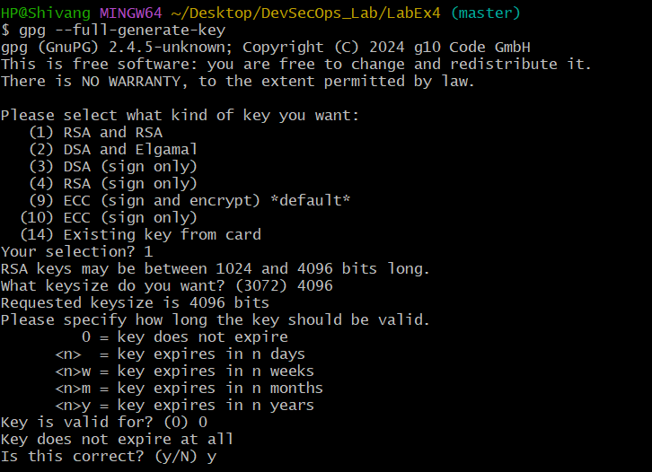
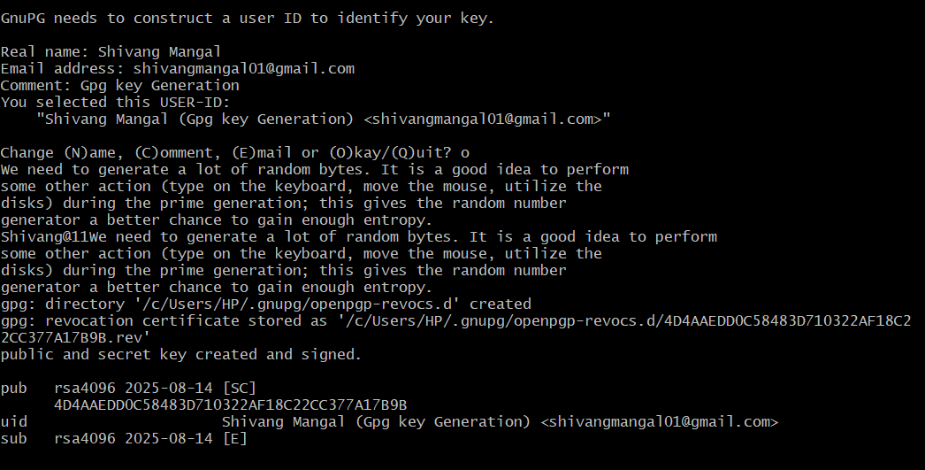
- Get your key ID
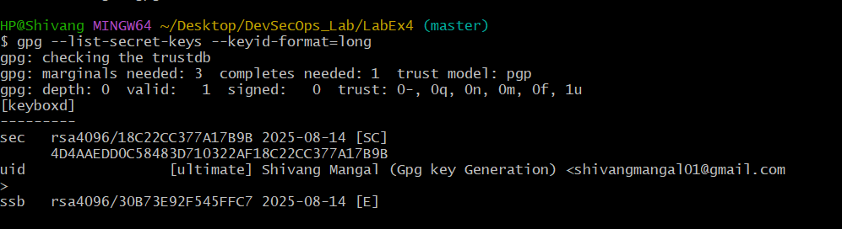
- Step 2 – Add GPG Key to GitHub
- Export your public key.
- Copy the output.
- Go to GitHub → Settings → SSH and GPG Keys → New GPG Key.
- Paste your key and save.
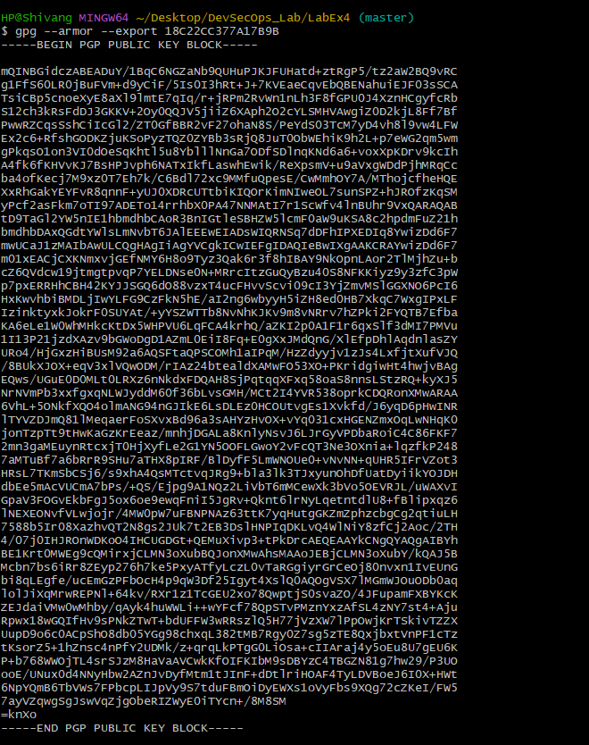


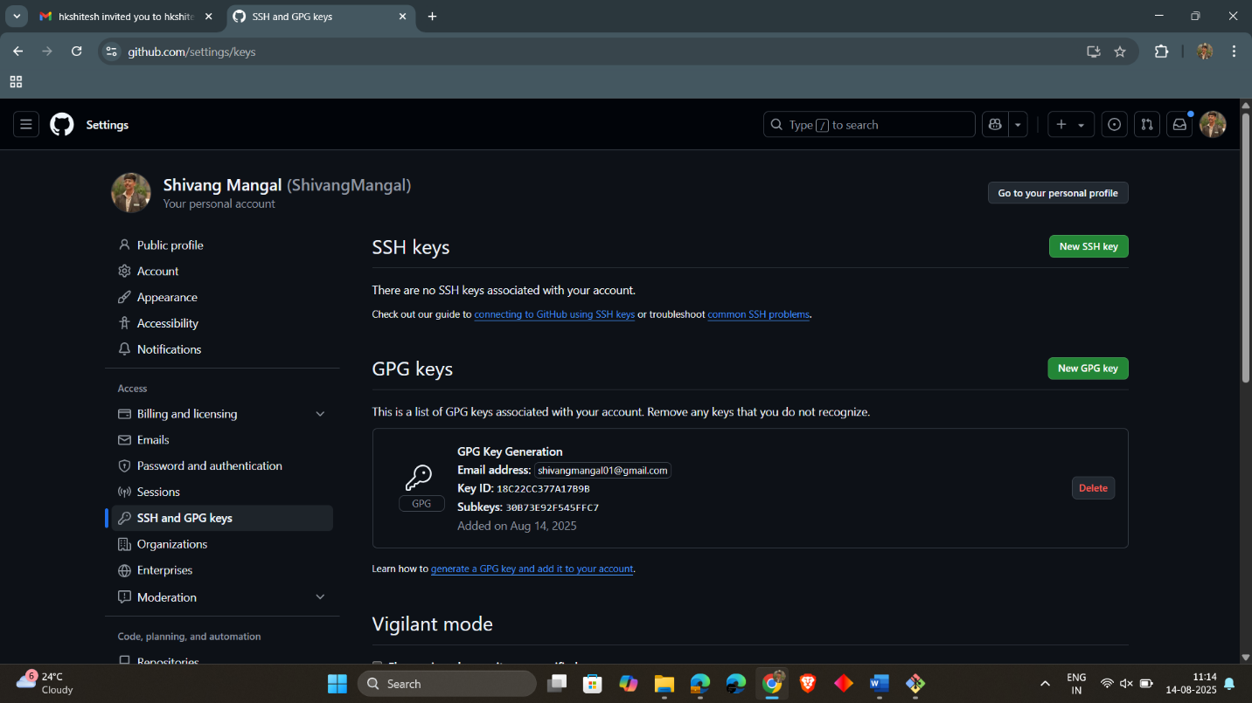
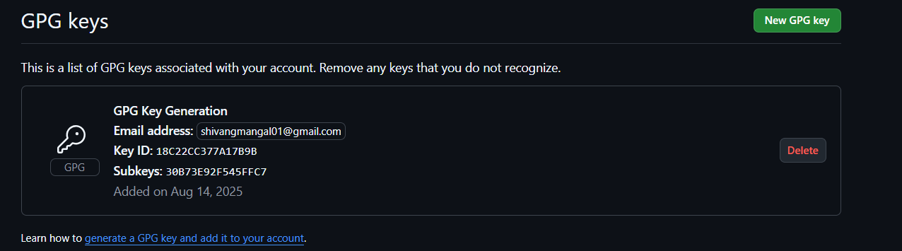

- Step 3 – Configure Git for Signed Commits
- Tell Git which key to use
- Enable signing for all commits
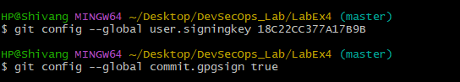
- Step 4 – Make a Signed Commit
- Clone your repo (or use an existing one)
- Edit or create a file
- Commit with signing
- Enter your GPG passphrase when prompted.
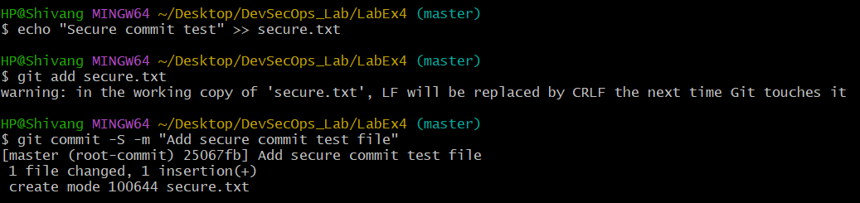
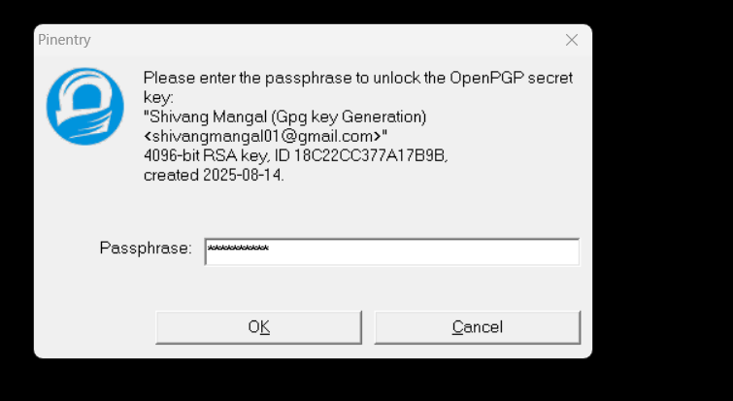

- Step 5 – Push and verify on GitHub
- Push the commit:
- Go to your repository on GitHub → Click the commit → You should see a green “Verified” badge.
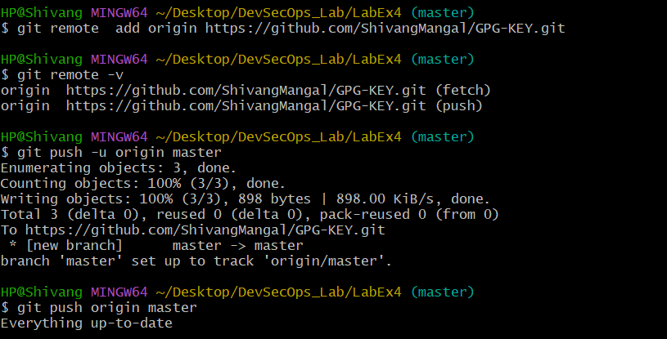
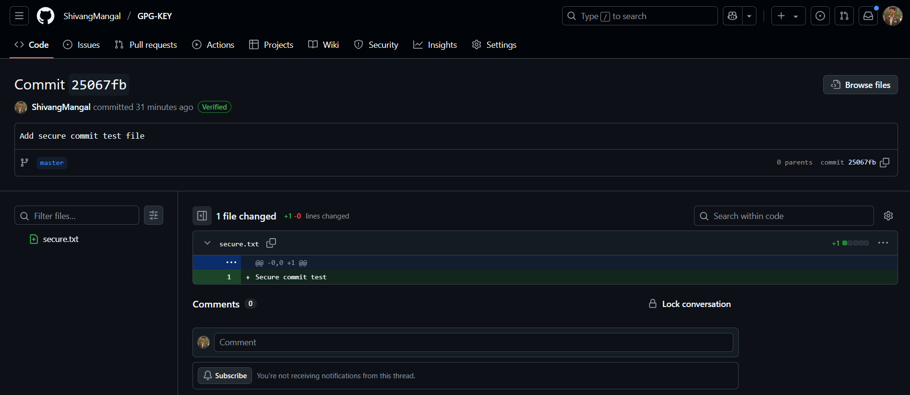
- Step 6 – Local Verification of Commit
This will display the GPG verification details locally.
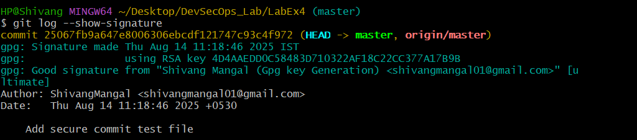
Use Case: -
Signed commits prevent identity spoofing in collaborative projects, ensuring only verified authors can make trusted changes in critical codebases.

